FINSIGHT AI

PERSONAL FINANCE BEHAVIOUR ANALYSIS AND SPENDING PREDICTION SYSTEM

A PROJECT REPORT
for

CS23533 FOUNDATIONS OF ARTIFICIAL INTELLIGENCE

Submitted by

240701208 – JANANI G
240701192 – HIMESH NIRANJHAN A

III YEAR B.E.
in
COMPUTER SCIENCE AND ENGINEERING


DEPARTMENT OF COMPUTER SCIENCE AND ENGINEERING
RAJALAKSHMI ENGINEERING COLLEGE
THANDALAM, CHENNAI 602 105
OCTOBER 2026

BONAFIDE CERTIFICATE
Certified that this project report “FINSIGHT AI: PERSONAL FINANCE BEHAVIOUR ANALYSIS AND SPENDING PREDICTION SYSTEM” is the bonafide work of “JANANI G (240701208) and HIMESH NIRANJHAN A (240701192)” who carried out the project work under my supervision.

Student Signature with Name
1. JANANI G
2. HIMESH NIRANJHAN A

Submitted for the Practical Examination held on ____________________

SIGNATURE OF THE SIGNATURE OF THE FACULTY INCHARGE INTERNAL EXAMINER

TABLE OF CONTENTS

CHAPTER NO. | TITLE | PAGE NO.
 | ABSTRACT | iii
1 | INTRODUCTION | 1
2 | LITERATURE REVIEW | 4
3 | PROPOSED SYSTEM | 9
3.1 | System Overview | 9
3.2 | PEAS Description of the Finance Agent | 9
3.3 | Architecture | 10
3.4 | Data Flow in the Planning Cycle | 11
3.5 | Key Design Decisions | 12
3.6 | Non Functional Requirements | 13
3.7 | Use Cases | 14
4 | MODULES DESCRIPTION | 17
4.1 | Module 1: Transaction Ingestion and Categorisation | 17
4.2 | Module 2: Behaviour Analysis and Clustering | 18
4.3 | Module 3: Anomaly Detection | 19
4.4 | Module 4: Spending Prediction | 20
4.5 | Module 5: Budget Search with A* and Local Search | 21
4.6 | Module 6: Constraint Satisfaction | 22
4.7 | Module 7: Knowledge Base and Logical Inference | 25
4.8 | Module 8: Adaptive Recommendation with Q-Learning | 26
4.9 | Module 9: Web Application and Explanations | 27
4.10 | Worked Example (Hypothetical) | 28
5 | IMPLEMENTATION PLAN AND EVALUATION | 31
6 | CONCLUSION AND FUTURE WORK | 39
7 | REFERENCES | 41

ABSTRACT
Most people cannot say, at the end of a month, where their money went and why. Bank statements list hundreds of small transactions that are hard to read as patterns, and budgeting tools usually describe what has already been spent rather than what is likely to happen next. FinSight AI is a proposed intelligent system that analyses a user's transaction history, groups spending into behaviour profiles, flags unusual transactions, predicts next month's spending for each category, and recommends a monthly budget that satisfies the user's own constraints such as a savings target and essential minimums.

This report describes the problem, the architecture, the nine modules, the planned implementation and the evaluation protocol. The system is at the design stage. No code has been run and no results are reported. Every performance figure in this report is a target to be tested, and the evaluation chapter defines how each target will be measured, against which baselines, and on which data. The report is written so that the implementation can be checked against the stated requirements once it exists.

CHAPTER 1 INTRODUCTION
1.1 Problem Statement
Planning personal spending is difficult for four reasons that FinSight AI addresses directly.
- Spending is irregular. Category totals vary by weekday, by month and by event, so a simple average is a poor guide to what will be spent next month.
- Budgets are constrained. Income is fixed, essentials must be met, and a savings target must be reached. Every allocation is a trade-off, and an arbitrary split can violate a constraint the user cares about without the user noticing.
- Unusual transactions are hard to judge. A large or unfamiliar payment may be an error, a fraudulent charge, or a genuine one-off. Flagging every outlier overwhelms the user, while missing a real problem is costly.
- Advice is opaque. Recommendations from a black-box model are difficult to trust or act on. A user needs to know which rule, pattern or calculation produced each alert.

1.2 Objectives
- To categorise transactions and summarise spending behaviour per user and per category, using rules that a user can inspect.
- To group users into behaviour profiles, such as savers, balanced spenders and high spenders, so that recommendations can be compared across similar users.
- To detect unusual transactions with an unsupervised anomaly score and to report the reason for each alert.
- To predict next month's spending for each category and compare the prediction with simple baselines using time-based validation.
- To generate a feasible monthly budget with A* search and local search, subject to a constraint satisfaction model of the user's income, savings target and essential minimums.
- To adapt recommendations to the user's responses with a reinforcement learning component.
- To present the results in a web application that works on a phone and on a desktop.
- To evaluate each component against stated baselines and report the results honestly, including failures.

1.3 Scope
The system is designed for one user's transaction history in one currency at a time. The inputs are transactions with a date, amount, description and optional merchant name, together with a profile containing monthly income, household size, a savings target and any fixed costs. The outputs are a behaviour summary, anomaly alerts, category-level predictions, a recommended budget, and a short explanation for each.

1.4 Limitations
FinSight AI does not connect to live bank accounts in its first version. It does not give investment advice, does not move money, and does not replace professional financial advice. Predictions depend on the amount and quality of history available. With fewer than six months of data, the system reports that its predictions are unreliable rather than producing a confident forecast. Cash spending, transactions in other accounts and money given to family members are not visible to the system and will appear as unexplained variation.

1.5 Contributions
The project's contribution is the integration. Each technique is established in the literature, as Chapter 2 shows, but the combination of these techniques in one personal finance system, with each recommendation traceable to a rule, a model output or a search result, has not been packaged for this use in the way the report describes. The contribution is therefore a design that joins these components, a clear division of responsibilities between them, and an evaluation plan that tests each part against a simple alternative.

CHAPTER 2 LITERATURE REVIEW

2.1 Intelligent Agents and Problem Formulation
Russell and Norvig (2021) define an intelligent agent as a system that perceives its environment through sensors and acts on it through actuators, with its behaviour judged by a performance measure. They describe the PEAS framework (performance measure, environment, actuators, sensors) as a way to specify an agent before building it, and they distinguish simple reflex, model-based, goal-based, utility-based and learning agents. Their treatment of partially observable environments is directly relevant, because a bank feed reveals only part of a person's financial life.

2.2 Expense Categorisation
Transaction categorisation is usually treated as text classification on merchant descriptions. Rule-based matching is transparent and easy to audit, but brittle when descriptions change. Supervised classifiers trained on labelled transactions generalise better but require labels that a new user does not have. FinSight AI uses a two-stage approach: deterministic rules and a user-editable merchant dictionary handle known merchants, and a classifier handles the remainder, with every assignment shown to the user for correction.

2.3 Behaviour Clustering
MacQueen (1967) introduced k-means clustering, which partitions observations into k groups by minimising within-group squared distance. It remains the most common clustering method for customer segmentation because it is simple and scales to large data. Its weaknesses are sensitivity to the choice of k and to outliers, and an assumption of roughly spherical clusters. Rousseeuw (1987) proposed the silhouette coefficient as a way to measure how well each observation fits its cluster relative to the next nearest cluster, and it is a standard basis for choosing k. For a small number of users, a silhouette score close to zero is a warning that the clusters are not meaningfully separated, and the system should say so.

2.4 Spending Forecasting
Forecasting spending is a time-series problem with strong seasonality and short histories. Hyndman and Athanasopoulos (2021) recommend that every forecasting method be compared with simple benchmarks, such as the naive forecast that next month equals this month and the seasonal naive forecast that next month equals the same month last year, before a complex model is trusted. They also stress time-based validation, where the model is trained on earlier periods and tested on later ones, because random splits leak future information into the training data.

2.5 Anomaly Detection
Liu, Ting and Zhou (2008) proposed the Isolation Forest, an unsupervised method that isolates observations by repeatedly selecting a random feature and a random split value. Anomalous points tend to be isolated in fewer splits. The anomaly score is derived from the average path length, normalised by the expected path length of an unsuccessful binary search tree. Because it needs no labels and scales linearly with the number of observations, it suits transaction data, where confirmed fraud labels are rare and unavailable to a single user.

2.6 Informed and Local Search
Hart, Nilsson and Raphael (1968) introduced A*, a best-first search that orders nodes by the cost so far plus a heuristic estimate of the remaining cost. If the heuristic never overestimates the true remaining cost, A* returns an optimal path. Russell and Norvig (2021) present consistency as a stronger condition that guarantees each node is expanded once. Local search methods such as hill climbing and simulated annealing move from one complete solution to a neighbouring one and do not guarantee optimality. Simulated annealing accepts some worse moves with a probability that falls as a temperature parameter decreases, which allows escape from local optima.

2.7 Constraint Satisfaction
A constraint satisfaction problem (CSP) consists of variables, each with a domain of possible values, and constraints that restrict which combinations are allowed. Russell and Norvig (2021) describe backtracking search with the minimum-remaining-values heuristic, which assigns the most constrained variable first, the least-constraining-value heuristic for ordering values, forward checking to remove values that become impossible, and arc consistency for propagating restrictions. These methods are well suited to a budget, because the constraints (total spending not exceeding income, a savings floor, essential minimums) are explicit and the domains are small.

2.8 Knowledge Representation and Logical Inference
Propositional logic represents facts as symbols that are true or false and combines them with connectives. Inference by resolution or by forward and backward chaining over Horn clauses allows conclusions to be derived from rules. First-order logic extends this with variables and quantifiers, so a single rule can apply to every category or every user. Russell and Norvig (2021) describe these methods and their trade-offs between expressiveness and tractability.

2.9 Comparative Summary
Table 2.1 Reviewed techniques, their use, and the gap addressed by FinSight AI
Technique and source | Problem addressed | Gap for personal finance | FinSight AI response
PEAS agents, Russell and Norvig (2021) | Specifying an intelligent agent | Toy environments; no finance-specific performance measure | Finance-specific PEAS in Section 3.2
k-means, MacQueen (1967); silhouette, Rousseeuw (1987) | Grouping users into behaviour profiles | Choice of k; weak separation with few users | Silhouette reported; system states when clusters are weak
Forecasting benchmarks, Hyndman and Athanasopoulos (2021) | Predicting category spending | Complex models trusted without benchmarks | Naive and seasonal naive baselines
Random forest, Breiman (2001) | Non-linear spending prediction | No native time awareness | Lagged and calendar features; compared with linear model
Isolation Forest, Liu et al. (2008) | Unsupervised anomaly detection | Scores are not probabilities | Score paired with rule-based reason
A*, Hart et al. (1968) | Low-cost path through budget changes | Needs admissible heuristic | Heuristic proven admissible in Section 4.5
CSP and backtracking, Russell and Norvig (2021) | Feasible budgets | First feasible solution may be poor | Optimisation criterion added to feasibility
Q-learning, Watkins and Dayan (1992) | Adaptive recommendations | Reward can reward ignored advice | Reward based on acceptance and outcome
Rule-based inference, Russell and Norvig (2021) | Explainable alerts | Rules must be maintained | Small rule base with plain-language text

2.10 Research Gap
The reviewed literature supplies strong components for each part of the problem, but the parts are usually studied in isolation. Categorisation, forecasting, anomaly detection and budget optimisation appear in separate papers, each with its own data and evaluation. A personal finance system needs them to share one representation of the user, so that a predicted overspend can trigger a feasible budget, an alert can cite a rule, and a recommendation can be learned from the user's response. FinSight AI addresses this by defining one agent, one state representation and one evaluation plan that covers all modules.

CHAPTER 3 PROPOSED SYSTEM

3.1 System Overview
FinSight AI takes a user's transactions and profile as input and returns four outputs: a behaviour summary, a list of anomaly alerts with reasons, a category-level forecast for the next month, and a recommended budget with a short explanation. Each output can be traced to a rule, a model or a search result. The user can see the evidence and can correct an input, such as a mislabelled merchant, which then changes the downstream results.

3.2 PEAS Description of the Finance Agent
Following Russell and Norvig (2021), the finance agent is specified by its performance measure, environment, actuators and sensors.
Table 3.1 PEAS description of the FinSight AI agent
Element | Description
Performance measure | Forecast error (MAE) per category; precision of alerts; share of recommended budgets feasible; share of recommendations accepted; change in share of months within budget
Environment | The user’s transaction history, income, savings target, fixed costs and corrections; partially observable, since cash spending and other accounts are invisible; sequential, since each month affects the next; stochastic, since spending varies
Actuators | Alert notifications; dashboard updates; budget recommendations; prompts for category correction; explanation text
Sensors | Transaction feed or uploaded statement; user edits to categories; budget acceptance or rejection; profile form

3.3 Architecture
The system has five layers. Each layer reads only from the layer below it, so that a change in data source or algorithm stays within its own layer. Table 3.2 lists the layers and the modules they contain.

Table 3.2 Architecture layers, components and syllabus units
Layer | Components | Syllabus unit
Presentation | Web application: dashboard, alerts, budget view, reports, settings | Unit I (agent actuators)
Application service | API gateway, planning cycle controller, explanation generator | Unit I
Reasoning | Knowledge base and inference engine; CSP solver; A* and local search; reinforcement learner | Units II, III, IV
Learning | Categoriser; clustering; anomaly detector; forecaster | Unit V
Data | Transaction store, user profile store, budget history, rule base, model registry | Unit I (environment model)

Figure 3.1 is a textual representation of the data flow. Transactions enter at the top, pass through categorisation and feature extraction, and feed the learning layer. The learning layer outputs predictions and scores that become facts for the knowledge base. The reasoning layer uses these facts and the user's constraints to produce a budget and explanations, and the presentation layer shows them.

User inputs: transactions, profile, corrections, responses
|
v
[Data layer] --> [Categorisation and features]
| |
| v
| [Learning layer]
| clustering | anomaly scores | forecasts
| |
v v
[Knowledge base: facts from learning + profile]
|
v
[Reasoning layer]
CSP feasibility -> A* / local search -> budget
Rule inference -> explanations
Q-learning -> recommendation choice
|
v
[Presentation layer: dashboard, alerts, reports]

3.4 Data Flow in the Planning Cycle
The planning cycle has eight steps. First, new transactions are validated: dates must be parseable, amounts must be numeric, and duplicates are removed using date, amount, description and a sequence number. Second, each transaction is categorised using the merchant dictionary and then the classifier. Third, monthly totals per category are computed and stored. Fourth, behaviour features are updated and users are assigned to a cluster. Fifth, anomaly scores are computed for the new transactions. Sixth, forecasts for the next month are produced. Seventh, the budget is planned using the CSP and the search methods. Eighth, the explanation generator writes the reasons for each output, drawing on the rules that fired and the values used.

3.5 Key Design Decisions
Several decisions shape the rest of the report. Table 3.3 records each decision with its reason and the alternative that was rejected.
Table 3.3 Key design decisions
Decision | Reason | Alternative rejected and why
Monthly planning cycle rather than real-time budgeting | Forecasts and budgets are meaningful at monthly scale; avoids noisy daily targets | Daily budgets: too noisy for a single user with limited history
Rules plus classifier for categorisation | Transparent for known merchants; classifier covers the rest | Classifier only: opaque and needs labels a new user lacks
Unsupervised anomaly detection | Confirmed fraud labels are unavailable to one user | Supervised fraud model: no labelled data
Linear regression as the main forecaster, random forest as comparison | Transparent and easy to explain; random forest tests whether non-linearity helps | Deep sequence models: too little data per user
A* with an admissible heuristic for budget change | Optimal result with respect to a clear cost; traceable path of changes | Pure local search: no guarantee and harder to explain
CSP for feasibility, search for optimality | Constraints are explicit and must always hold | Penalty-only optimisation: infeasible budgets can be returned
Q-learning over a small state space | Learns from acceptance; small state space suits one user | Deep reinforcement learning: needs far more interaction data
Explanations generated from rule and model outputs | Every recommendation can be checked by the user | Post-hoc explanation methods only: harder to tie to finance rules

3.6 Non-Functional Requirements
Table 3.4 Non-functional requirements
ID | Requirement | Planned measure
NFR1 | Privacy: data stored on the user’s machine or in an encrypted store; no sharing with third parties | Design review; no external calls with transaction data
NFR2 | Explainability: every alert and recommendation carries a reason | Share of outputs with a reason; target 100%
NFR3 | Responsiveness: a monthly plan computed within a few seconds for a year of transactions | Measured on the test machine; target to be set after profiling
NFR4 | Reproducibility: fixed random seeds and stored model versions | Re-running the test suite gives identical outputs
NFR5 | Usability: core tasks completable on a 390 px wide screen | Layout check at standard phone and desktop widths

3.7 Use Cases
Three use cases describe how a user interacts with the system over a month. Each case lists the actor, the trigger, the main flow and the alternative flows. They are used to derive the test cases in Chapter 5 and to check that each module is needed.

3.7.1 Use Case UC1: Monthly Import and Review
Table 3.5 Use case UC1, monthly import and review
Field | Description
Actor | Account holder
Trigger | The user exports last month’s transactions from the bank as a CSV file and opens FinSight AI
Preconditions | Profile exists with income, household size and savings target
Main flow | 1. User uploads the CSV. 2. System validates rows and rejects malformed ones with reasons. 3. System categorises each row using merchant rules and the classifier. 4. System shows the dashboard with the monthly total, the category breakdown and the number of rows flagged for review. 5. User corrects flagged categories; each correction is saved as a merchant rule.
Alternative flow A | If more than 20% of rows are rejected, the system stops the import and asks the user to check the file format before continuing.
Postconditions | Transactions stored; categories final; behaviour summary and anomaly scores updated
Related modules | Modules 1, 2, 3 and 9

3.7.2 Use Case UC2: Alert on an Unusual Transaction
Table 3.6 Use case UC2, alert on an unusual transaction
Field | Description
Actor | Account holder; the system acts as the agent
Trigger | A new transaction is imported or entered during the month
Preconditions | At least one month of history for the user; anomaly model trained
Main flow | 1. System categorises the transaction. 2. System computes the isolation forest score. 3. Score exceeds the threshold set by the alert tolerance. 4. System derives the reasons from the rules in Module 7, for example amount above the 95th percentile for the category and a new merchant. 5. Alert appears on the dashboard with the reasons and two buttons: confirm and dismiss. 6. User’s response is recorded as an event.
Alternative flow A | If the user dismisses the alert, the response is stored and the threshold for that category is not changed automatically, to avoid learning from one response.
Postconditions | Alert stored with reasons and user response; event available to Module 8
Related modules | Modules 1, 3, 7 and 9

CHAPTER 4 MODULES DESCRIPTION

4.1 Module 1: Transaction Ingestion and Categorisation
Syllabus link: Unit I, the agent's sensors and percepts. The module receives raw transactions and produces categorised, validated records. It is the agent's sensor layer, and its output defines the environment that the other modules observe.

4.1.1 Validation
Each transaction is checked for a parseable date, a numeric amount, and a non-empty description. Records that fail are kept in a rejected list with the reason, so that the user can correct them. Duplicates are identified by the tuple of date, amount, normalised description and an occurrence index. Two identical tuples on the same day are treated as separate transactions if they appear as separate lines in the source file.

4.1.2 Categorisation
Categorisation proceeds in two stages. The first stage normalises the description by lower-casing, removing digits and reference codes, and matching against a merchant dictionary of known patterns. A match assigns the category directly and records the rule that matched. The second stage applies a text classifier to descriptions that do not match. The classifier uses a bag of character n-grams with a linear model, which is simple, fast and tolerant of misspellings. Its confidence is the predicted probability of the top class, and assignments below a confidence threshold are marked as uncertain and shown to the user first.

function categorise(transaction):
text <- normalise(transaction.description)
for (pattern, category) in merchant_dictionary:
if pattern occurs in text:
return (category, source='rule:' + pattern, confidence=1.0)
probs <- classifier.predict_proba(char_ngrams(text))
category <- argmax(probs)
confidence <- max(probs)
if confidence < 0.60:
return (category, source='classifier', confidence, flag='review')
return (category, source='classifier', confidence)

4.1.3 Outputs
The module outputs a categorised transaction table with columns for category, category source, confidence and review flag. These columns feed every other module. A user correction is written back to the merchant dictionary as a new rule, so that the same merchant is categorised correctly in future months.

4.2 Module 2: Behaviour Analysis and Clustering
Syllabus link: Unit V, unsupervised learning. The module computes a feature vector for each user and groups users into profiles.

4.2.1 Features
For each user and each full month, the module computes the following features: total spending; the share of spending in each of the seven categories; the savings rate, defined as one minus spending divided by income; the coefficient of variation of weekly spending, which measures irregularity; the share of spending in the last week of the month; and the number of distinct merchants. Features are computed on a rolling window of the last six full months, so that profiles can change as behaviour changes.

4.2.2 Clustering
The feature vectors are standardised to zero mean and unit variance and clustered with k-means. The number of clusters k is chosen from {2, 3, 4} by the silhouette score, with a preference for smaller k when two values are within 0.02 of each other. The three named profiles are assigned by inspection of the cluster centres: savers have the highest savings rate and lowest irregularity, high spenders have the lowest savings rate, and balanced spenders lie between. A cluster that does not match any of the three is labelled 'irregular' and treated as a separate profile.

The silhouette score for a set of users is
s(i) = (b(i) - a(i)) / max(a(i), b(i))
a(i) = mean distance from user i to other users in its cluster
b(i) = smallest mean distance from user i to users in any other cluster
S = mean of s(i) over all users

4.3 Module 3: Anomaly Detection
Syllabus link: Unit V, unsupervised learning, and Unit IV, rules for explanation. The module scores each new transaction for unusualness and attaches a reason.

4.3.1 Isolation Forest Score
An isolation forest of t trees is trained on a sample of ψ transactions from the user's history, with features that describe the transaction: its amount, the log of its amount, its category, its weekday, the hour where available, and the days since the last transaction in the same category. Each tree is a random partition built by choosing a random feature and a random split between its minimum and maximum until each point is isolated or a height limit is reached. For a transaction x, the anomaly score is
s(x, n) = 2 ^ ( - E[h(x)] / c(n) )
c(n) = 2 H(n - 1) - 2(n - 1) / n
H(i) = ln(i) + 0.5772156649 (Euler constant)

4.3.2 Reason Generation
A score on its own is hard to act on, so each alert is paired with the rule that explains it. The module compares the transaction with the user's history in the same category. If the amount is above the user's 95th percentile in that category, the reason is recorded as an amount outlier. If the category is one the user has rarely used, the reason is recorded as a category outlier. If the merchant has not appeared before, the reason is recorded as a new merchant. An alert can carry several reasons, and the reasons are ordered by how strongly each one departs from the history.

4.4 Module 4: Spending Prediction
Syllabus link: Unit V, supervised learning. The module predicts next month's spending for each of the seven categories.

4.4.1 Target and Features
The target for category c in month m is the total spending in that category, y(c, m). The features are the lagged totals for the previous one, two and three months, the mean of the previous three months, the same month in the previous year where available, a seasonal index for the calendar month, the user's income, the household size, the savings target, and the number of days in the month. The lagged features make the model autoregressive, and the seasonal index captures recurring patterns such as festival or holiday spending.

4.4.2 Models and Baselines
Four models are compared. The first two are baselines: the naive forecast, which predicts that next month equals the latest month, and the seasonal naive forecast, which predicts that next month equals the same month one year earlier, falling back to the mean of the last three months where no earlier year is available. The third model is linear regression with ridge regularisation, which is transparent and whose coefficients can be shown to the user. The fourth is a random forest regressor with 300 trees and a minimum leaf size of five.

4.4.3 Validation
Validation is time-based. For each user with at least twelve months of history, the model is trained on the first months and tested on the following month, and the origin is moved forward one month at a time. This rolling-origin evaluation gives a set of forecast errors for each model and category. The primary error measures are mean absolute error and root mean squared error, reported per category and overall. Mean absolute percentage error is not used as a primary measure because it is undefined for months with zero spending in a category.

4.5 Module 5: Budget Search with A* and Local Search
Syllabus link: Unit II, informed and local search. The module finds a set of budget changes that moves the user from current spending towards a feasible budget at the lowest total disruption.

4.5.1 State and Goal
A state is a vector of monthly allocations b = (b1, ..., b7) over the seven categories, with the savings allocation as the remainder of income after the other categories. The start state is the forecast spending for the coming month. The goal is any state that satisfies every constraint of Module 6. The cost of a path is the total absolute change across all categories, summed over the moves, weighted by a category importance factor set by the user, so that a change to food may cost more than a change to entertainment if the user prefers it.

4.5.2 Admissible Heuristic
Let D be the sum over categories of the absolute difference between the current allocation and the nearest feasible allocation. Each move changes the total absolute deviation by at most s in the cost measure used, so the number of moves still needed is at least ceil(D / s). The heuristic h(b) = ceil(D / s) times the minimum cost of one move therefore never overestimates the remaining cost, and is admissible. Because a move changes only one category and the step cost is the same for every move of a category, the heuristic is also consistent when moves are costed by category weight, provided that the minimum weight is used in the calculation. The proof is given in Appendix C.

4.5.3 A* Procedure
function astar_budget(start, feasible):
g[start] <- 0
open <- priority queue ordered by f = g + h
push start with f = h(start)
while open is not empty:
n <- pop lowest f
if feasible(n): return path to n
for each move m from n:
c <- n.state after m
cost <- g[n] + weight(m)
if cost < g[c] (or c unseen):
g[c] <- cost; parent[c] <- n
push c with f = cost + h(c)
return NOT_FOUND

4.5.4 Explanation of the Path
Each returned path is converted into a list of changes, such as 'reduce entertainment by 5% of income' and 'increase savings by the same amount'. Each change is linked to the constraint or the forecast that motivated it, so that the explanation generator in Module 9 can state the reason.

4.6 Module 6: Constraint Satisfaction
Syllabus link: Unit III, constraint satisfaction problems and backtracking. The module defines what a feasible budget is and checks candidates against it.

4.6.1 Variables, Domains and Constraints
The variables are the monthly allocations for the seven categories. Each has a domain given by its lower and upper bounds, derived from the user's history and profile. Essential categories have lower bounds set by the household size and the stated minimum living cost. Discretionary categories have upper bounds set by the user's preference, with a default of their own 75th percentile over the last six months. The constraints are listed in Table 4.1.

Table 4.1 Constraints of the budget CSP
ID | Constraint | Type
C1 | Sum of all category allocations, including savings, equals monthly income | Equality
C2 | Savings allocation is at least the user’s savings target | Inequality
C3 | Food allocation is at least household size times the minimum food cost per person | Inequality, essential
C4 | Housing and utilities allocations are at least the fixed costs entered by the user | Inequality, essential
C5 | Entertainment allocation does not exceed the user’s discretionary limit | Inequality, preference
C6 | Each allocation lies inside its domain | Domain
C7 | Total of discretionary allocations does not exceed income minus essentials and savings | Inequality

4.6.2 Solving
The CSP is solved by backtracking search. Variables are ordered by the minimum-remaining-values heuristic, so that the variable with the fewest legal values is assigned first. Values for each variable are ordered by the least-constraining-value heuristic, so that the value that removes the fewest options from other variables is tried first. After each assignment, forward checking removes values from the domains of unassigned variables that conflict with the constraints. If any domain becomes empty, the algorithm backtracks. Because the domains are discretised in steps of 1% of income, the search space is small and the solver finds the feasible set quickly.

function backtrack(assignment):
if complete(assignment) and all constraints hold: return assignment
x <- unassigned variable with smallest current domain (MRV)
for v in domain(x) ordered by least constraining value:
assignment[x] <- v
pruned <- forward_check(x, v)
if no domain is empty:
result <- backtrack(assignment)
if result is not failure: return result
restore pruned values; remove assignment[x]
return failure

4.7 Module 7: Knowledge Base and Logical Inference
Syllabus link: Unit IV, knowledge-based agents, propositional and first-order logic, forward and backward chaining, and resolution. The module stores the rules used to interpret the learned facts and to explain the outputs.

4.7.1 Propositional Rules
Propositional logic is used for rules about a single category in a single month. Let H be the proposition that a category is high risk this month, O the proposition that spending exceeds the category limit, and R the proposition that the last two months both exceeded the limit. The rule set includes the following:

R1: O -> Warning(c)
R2: R -> HighRisk(c)
R3: HighRisk(c) and Essential(c) -> Alert(c)
R4: Anomaly(t) and NewMerchant(t) -> Review(t)
R5: Review(t) and not UserConfirmed(t) -> Alert(t)

4.7.2 First-Order Rules
First-order logic applies the same rules to every category and every user without repeating them. The following schemas are used:

forall c in Categories: exceeds(c, m) and exceeds(c, m-1) -> highRisk(c, m)
forall u in Users: savingsRate(u) >= target(u) -> onTrack(u)
forall t in Transactions: amount(t) > p95(category(t)) -> outlier(t)

Each schema is grounded by substituting the user's categories, months and transactions. Grounding produces a set of propositional facts over which forward chaining operates.

4.7.3 Forward and Backward Chaining
Forward chaining applies the rules to the facts as they arrive. When a new transaction is categorised and scored, the system adds the facts it produces, such as Outlier(t) or Over(c, m), and fires every rule whose premises are now satisfied, repeating until no new facts are derived. This is used during the month to raise alerts as they occur.

4.7.4 Rule Maintenance
The rule base is small by design, with about twenty rules in the first version. Each rule has a plain-language text, its formal form, the syllabus concept it illustrates, and a switch that the user can turn off. Rules that a user turns off are logged so that the evaluation can measure how often each rule is used and whether it changed decisions.

4.8 Module 8: Adaptive Recommendation with Q-Learning
Syllabus link: Unit V, reinforcement learning. The module learns which kinds of budget recommendation a user accepts and keeps to.

4.8.1 States, Actions and Rewards
A state is a tuple of the category with the largest forecast overspend, a bin of its overspend size (none, small, large), and the user's profile cluster. The state space is therefore 7 times 3 times the number of profiles, which is small enough for a tabular method. Three actions are available for the highlighted category: keep the allocation, reduce it by 5% of income, or reduce it by 10% of income. A recommendation is made for one category per month to avoid overwhelming the user.

4.8.2 Learning Rule and Policy
The learner uses the standard Q-learning update with learning rate α and discount factor γ:
Q(s, a) <- Q(s, a) + α [ r + γ max_a' Q(s', a') - Q(s, a) ]
policy: with probability ε choose a random action; otherwise choose argmax_a Q(s, a)

The default parameters are α = 0.2, γ = 0.7 and ε decaying from 0.2 to 0.02 over the first twelve months. The discount factor is kept moderate because the effect of a recommendation is usually visible within a month. Initial Q-values are set to zero, and a prior from the population profile is optionally used to speed learning for new users.

4.9 Module 9: Web Application and Explanations
Syllabus link: Unit I, the agent's actuators, and the explanation requirement of Unit IV. The module presents the outputs of the other modules and writes the explanations.

4.9.1 Screens
The application has five screens. The dashboard shows the month's total against the budget, the category breakdown, the forecast with its interval, and the number of active alerts. The alerts screen lists each alert with its score, its reasons and a button to confirm or dismiss it. The budget screen shows the recommended budget, the changes from current spending, and the explanation for each change. The reports screen shows the history of months, the profile, and the measured accuracy of the forecasts. The settings screen holds the profile, the savings target, the alert tolerance and the rule switches.

4.9.2 Explanations
Every displayed number is accompanied by a source line that names the module that produced it and the rule or method used. For example, a forecast line reads 'Forecast from the linear model, validated on the last six months, mean absolute error shown on the reports screen.' An alert line reads 'Flagged because the amount is above the 95th percentile for this category and the merchant is new.' The source line is written from the stored metadata, not generated freely, so that the explanation always matches the computation.

4.9.3 Responsive Layout
The layout uses a single column below 560 px and a side navigation above that width. Tables collapse to labelled rows on narrow screens so that no horizontal scrolling is needed. The colour scheme passes contrast checks for text and for the alert states, and alerts also use a text label so that colour is not the only signal.

4.10 Worked Example (Hypothetical)
This section walks through one month for a hypothetical user to show how the modules connect. The figures are invented for illustration and are not results. They show the form of each calculation, so that a reader can follow the reasoning and check the implementation against it once it exists.

Module 6 first computes the feasible domains. Food has a lower bound of 2 times the minimum food cost per person, which we take as 3,500, giving 7,000. Entertainment has an upper bound of 5,000 from the user’s discretionary limit. The sum of the essentials and the savings target is 14,000 + 3,000 + 7,000 + 9,000 = 33,000, which leaves 27,000 for the discretionary categories. The forecast discretionary total is 4,500 + 6,500 + 3,200 + 2,000 = 16,200, so the budget is feasible without any change. The CSP therefore returns a feasible set, but the forecast already satisfies every constraint except the entertainment limit, which the forecast exceeds by 1,500.

Module 5 then searches for the lowest-disruption budget that brings entertainment within its limit. The start state is the forecast. Each move changes one category by the step of 5% of income, which is 3,000 units. A single move that reduces entertainment by 3,000 units and increases savings by the same amount reaches entertainment at 3,500, within the limit of 5,000. The heuristic counts the remaining deviation of 1,500 units, and ceil(1,500 / 3,000) = 1, so the heuristic estimates one move. The move is the one found, and A* returns it at a cost equal to the category weight of entertainment.

The explanation generator then writes the reason. The source line reads that entertainment was forecast at 6,500 against a limit of 5,000, that a reduction of 3,000 units is the smallest step that satisfies the limit, and that the amount is added to savings to keep the total at income.

Module 3 runs during the month. Suppose a transaction of 4,200 units appears in entertainment with a new merchant name. The isolation forest score is computed on the features in Section 4.3.1. Suppose it exceeds the threshold. The reasons are that the amount is above the 95th percentile of the category and that the merchant has not appeared before. Module 7 applies rule R4 from Section 4.7.1, since the transaction is anomalous and the merchant is new, and derives Review(t). Because the user has not confirmed the transaction, rule R5 derives Alert(t). The alert appears with both reasons.

At month end, Module 8 computes the reward. Suppose the user accepted the budget and spent 3,600 units in entertainment, which is within the 3,500 planned allocation plus a 5% tolerance. The overspend is 100 units, which is under 5% of the planned allocation, so the reward is +0.5 under the rule in Section 4.8.1. The Q-value for the state and the action taken is updated with the learning rule. The example shows the mechanism; in practice the value will move gradually over many months.

CHAPTER 5 IMPLEMENTATION PLAN AND EVALUATION

This chapter describes how FinSight AI will be implemented and how each part will be evaluated. The work is at the design stage. The plan is stated in enough detail that the implementation can be checked against it, and the evaluation can be run without changing the protocol after the results are seen.

5.1 Technology Stack
Table 5.1 Planned technology stack
Area | Choice | Reason
Language | Python 3.11 or later | Mature machine learning and data libraries; readable for an academic report
Data handling | pandas and NumPy | Standard for tabular time-series work
Machine learning | scikit-learn | Provides k-means, silhouette, isolation forest, ridge regression, random forest and metrics; cited in Pedregosa et al. (2011)
Text classification | scikit-learn with character n-gram vectoriser | Simple, fast and tolerant of spelling variation
Search and reasoning | Custom implementation in Python | Keeps the A*, CSP and inference code visible for the report
Storage | SQLite for the first version | Single-file database; no server needed for a single user
Back end service | FastAPI | Typed endpoints and automatic documentation
Front end | Browser-based interface with responsive layout | Works on phone and desktop from one code base
Testing | pytest, with fixed random seeds | Reproducible tests of each module
Version control | Git | Records every change for the report

5.2 Data Design
The database has six tables. The transactions table holds one row per transaction, with a foreign key to the user and to the category. The categories table holds the seven category groups and any user sub-categories. The merchant rules table holds the dictionary used in the first categorisation stage. The profiles table holds the income, household size, savings target, fixed costs and alert tolerance. The budgets table holds each recommended budget with its status. The events table holds alerts, user responses and rewards, and is the source of the data for Module 8. Appendix A gives the full data dictionary.

Table 5.2 Main database tables
Table | Key fields | Purpose
transactions | id, user_id, date, amount, description, category, category_source, confidence | Transaction history and categorisation
categories | id, name, parent_id, is_essential | Category groups and sub-categories
merchant_rules | id, pattern, category, created_by, created_on | Dictionary for rule-based categorisation
profiles | user_id, monthly_income, household_size, savings_target, fixed_costs, alert_tolerance | Constraints and preferences
budgets | id, user_id, month, allocations, status, explanation | Recommended and accepted budgets
events | id, user_id, type, reference_id, payload, created_at | Alerts, responses, rewards

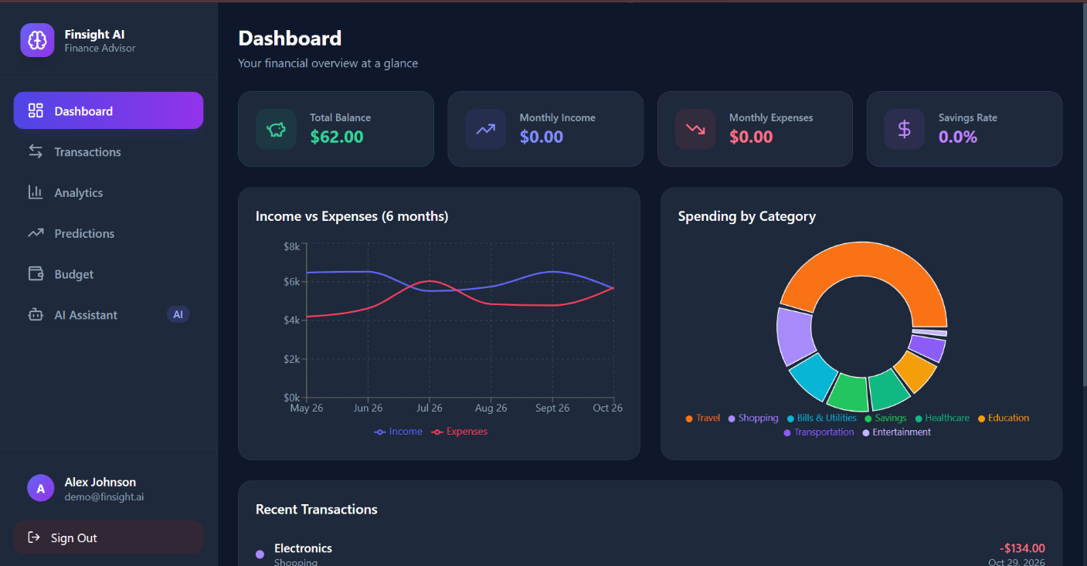

5.3 Interface Design
The interface is served by the back end as a set of endpoints. Table 5.3 lists the endpoints needed for the first version. Each endpoint accepts and returns JSON, and each returns an explanation field alongside its numerical results so that the presentation layer can show the reason with the number.
Table 5.3 Planned API endpoints
Method and path | Purpose | Module
POST /transactions/import | Upload a CSV and validate rows | Module 1
GET /transactions?month= | List categorised transactions for a month | Module 1
PATCH /transactions/{id} | Correct a category and update the merchant rule | Module 1
GET /summary?month= | Monthly totals per category and weekly breakdown | Module 2
GET /profile-cluster | Current behaviour profile and clustering silhouette | Module 2
GET /alerts?month= | Alerts with scores and reasons | Module 3
GET /forecast?month= | Next-month forecast per category with interval | Module 4
POST /budget/plan | Compute a feasible budget and the change path | Modules 5 and 6
GET /status?month= | Backward-chained status and its premises | Module 7
POST /recommendations/{id}/response | Record acceptance or rejection and update the learner | Module 8
GET /reports | History, forecast accuracy and rule usage | Module 9

5.4 Dataset Plan
No real user data is used in this project without the user’s consent, and no personal data is published in the report. The evaluation uses three kinds of data, each stated in the results with its source.
- Synthetic users. A generator creates households with income, fixed costs, a savings habit and a spending pattern drawn from stated distributions. Each synthetic user has a set of injected anomalies with known labels. The generator uses a fixed random seed, and its parameters are published with the code so that results can be reproduced.
- Public transaction data. Any public dataset of personal or household transactions that permits academic use, with its licence and citation given in the report. If no suitable public dataset is available, this part of the evaluation is omitted and the report says so.
- The author’s own records. Used only with the consent of each author, anonymised, with merchant names replaced by category tokens before analysis.

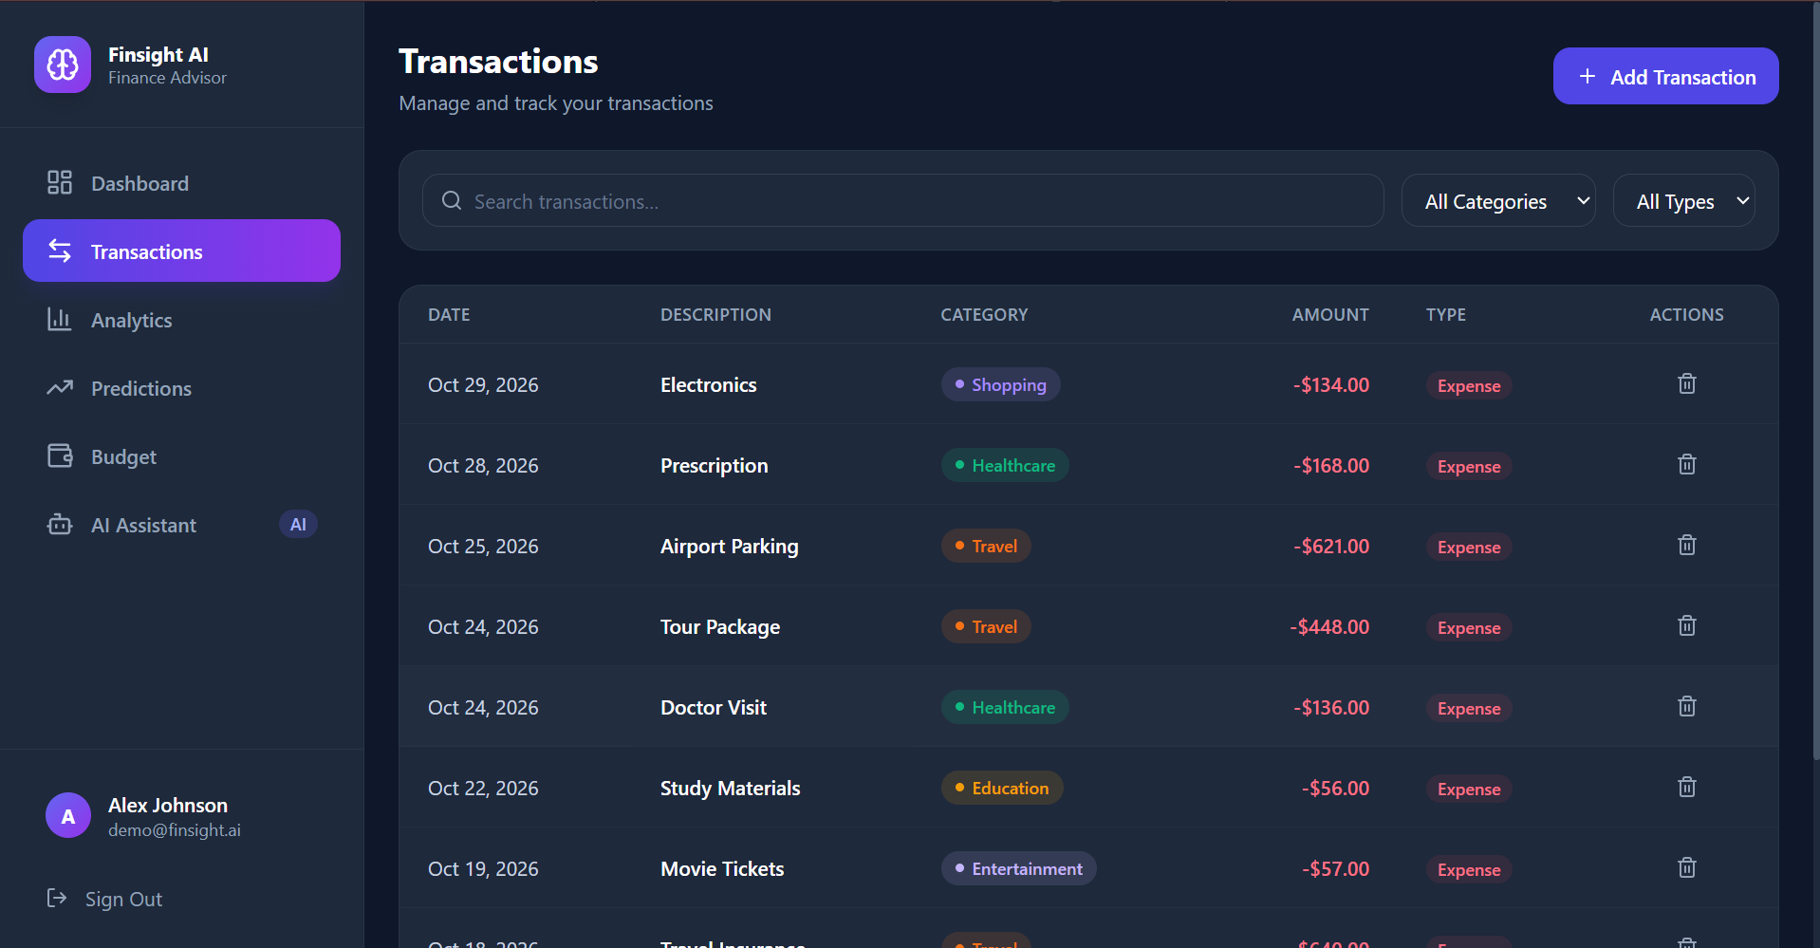

5.5 Experimental Protocol
The protocol is fixed before the experiments run. It has five parts.
- Splits. For each user with at least twelve months of history, forecasts are evaluated with rolling-origin validation as described in Section 4.4.3. No model parameter is tuned on the test months.
- Repetition. Each stochastic component, including the isolation forest, the random forest, k-means and Q-learning, is run with five seeds, and the mean and range are reported.
- Baselines. Every module is compared with a simple alternative: the seasonal naive forecast for Module 4, a fixed-threshold rule for Module 3, a greedy proportional cut for Module 5, and a bandit for Module 8.
- Ablation. The contribution of the constraint model is tested by removing Module 6 and checking how often the resulting budget violates the savings target or essential minimums.
- Reporting. Negative results are reported in the same way as positive ones. Where a method does not beat its baseline, the report says so and gives the reason the data suggests.

5.6 Test Plan
Automated tests cover each module and their connections. The unit tests check individual functions, such as the validation of a malformed row, the rule-based categorisation of a known merchant, and the isolation forest score of a constructed outlier. The algorithm tests check A* against an exhaustive search on small budgets, verify that every returned budget satisfies the constraints, and verify that the Q-learning update matches a hand-calculated example. The integration tests run the full planning cycle on a synthetic user and check that the outputs are consistent with each other: an alert must cite a rule, and a budget must satisfy the constraints the status reports.

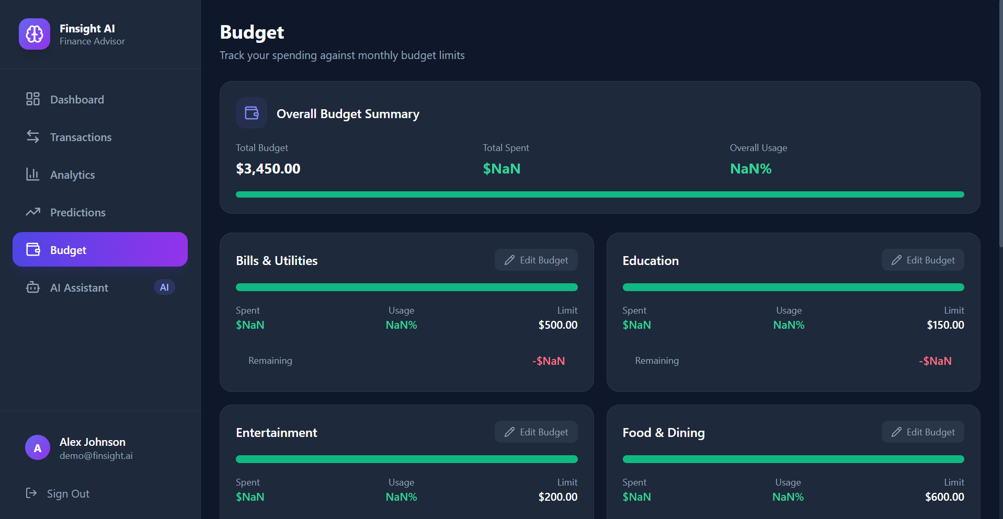

5.7 Work Plan
The work is planned over the semester in six stages. Stage one fixes the requirements and the data design, as in Chapter 3. Stage two builds Modules 1 and 2 with their tests. Stage three builds Modules 3 and 4 and their baselines. Stage four builds Modules 5, 6 and 7, with the search and constraint code tested against exhaustive checks. Stage five builds Module 8 and the presentation layer. Stage six runs the evaluation protocol, writes the results and revises this report. Each stage ends with a review of the tests before the next stage begins.

5.8 Summary of Planned Outputs
The completed project is expected to produce five artefacts. Each is listed with its format and the chapter that specifies it, so that the final submission can be checked against this report.

CHAPTER 6 CONCLUSION AND FUTURE WORK

6.1 Conclusion
FinSight AI is designed as one intelligent system that joins five units of the Foundations of Artificial Intelligence syllabus in a personal finance application. The agent specification gives the system a clear performance measure and a defined environment. Informed and local search find low-cost budget changes.

Constraint satisfaction ensures that every budget respects the user's income, savings target and essential needs, and logical inference produces explanations that can be checked. Machine learning provides the behaviour profiles, anomaly scores and forecasts that feed these components, and reinforcement learning adapts the recommendations to the user's responses.

The report makes no claim about results. The system has not yet been built, and the targets in Chapter 5 are to be tested. If the planned tests show that a component does not beat its baseline, the report will state that and the design will be revised.

6.2 Future Work
- Bank connection. A read-only connection to bank feeds, with user consent, would remove manual import and allow real-time anomaly scoring.
- Generative explanations. A generative model could rewrite the rule-based explanations in plain language, provided that every statement is checked against the stored source line before it is shown.
- Multi-month planning. Extending the search from one month to a horizon of several months would allow savings goals to be planned over time rather than month by month.
- Household planning. Several users sharing one budget would require a game-theoretic treatment of how contributions are allocated, which the two-player model in Section 2.8 only begins to address.
- Richer forecasting. Hierarchical forecasting across categories and sub-categories, and an evaluation of whether sequence models help when enough users are available.
- Calibrated alerts. Learning the alert threshold for each user from the user’s confirmations, using the events table.
- Rule learning. Proposing new rules from patterns the user repeatedly confirms, while keeping the rule base readable.

6.3 Limitations Revisited
The limitations stated in Section 1.5 remain. Forecasts for new users are weak, categorisation depends on the quality of descriptions, and the explanations describe the system's reasoning, not the user's psychology. The system informs a decision and does not make it.

CHAPTER 7 REFERENCES
- Breiman, L. (2001) ‘Random forests’, Machine Learning, 45(1), pp. 5–32.
- Hart, P.E., Nilsson, N.J. and Raphael, B. (1968) ‘A formal basis for the heuristic determination of minimum cost paths’, IEEE Transactions on Systems Science and Cybernetics, 4(2), pp. 100–107.
- Hyndman, R.J. and Athanasopoulos, G. (2021) Forecasting: Principles and Practice. 3rd edn. Melbourne: OTexts. Available at: https://otexts.com/fpp3/
- Liu, F.T., Ting, K.M. and Zhou, Z.-H. (2008) ‘Isolation forest’, Proceedings of the 8th IEEE International Conference on Data Mining, pp. 413–422.
- Lusardi, A. and Mitchell, O.S. (2014) ‘The economic importance of financial literacy: theory and evidence’, Journal of Economic Literature, 52(1), pp. 5–44.
- MacQueen, J. (1967) ‘Some methods for classification and analysis of multivariate observations’, Proceedings of the Fifth Berkeley Symposium on Mathematical Statistics and Probability, 1, pp. 281–297.
- Nash, J. (1950) ‘Equilibrium points in n-person games’, Proceedings of the National Academy of Sciences, 36(1), pp. 48–49.
- Pedregosa, F. et al. (2011) ‘Scikit-learn: machine learning in Python’, Journal of Machine Learning Research, 12, pp. 2825–2830.
- Rousseeuw, P.J. (1987) ‘Silhouettes: a graphical aid to the interpretation and validation of cluster analysis’, Journal of Computational and Applied Mathematics, 20, pp. 53–65.
- Russell, S. and Norvig, P. (2021) Artificial Intelligence: A Modern Approach. 4th edn. Harlow: Pearson.

